ZAVGR000 - Subcon PPV Report- Functional Specification

VERSION: 1.0
LAST UPDATED: 11/22/2019

DOCUMENT CONTROL:

REVISION HISTORY:

Version # | Date Modified | Modified By | Brief Description of Change
1.0 | 5/22/2020 | Murali M Ganta | Initial Draft
2.0 | 06/29/2020 | Murali M Ganta | Display all consumed materials in Separate lines
3.0 | 07/8/2020 | Murali M Ganta | New fields added highlighted in yellow
4.0 | 08/27/2020 | Murali M GANTA | Def#4464 – PO and Item wise sumarize
5.0 | 12/8/2020 | Murali M Ganta | INC06340089: Fiscal year mismatch b/w Mat doc and Accounting doc and Adding Save button to Layout
6.0 | 03/19/2021 | Yashwanth Voora | INC06664870: Bug in the Quantity column in the report.

APPROVALS:

Author | Murali M Ganta | Date Created: | 5/22/2020
Functional Team Lead | Sapan Shenoy/Daniel Lee | Signature and Date Approved:
Business Process Owner | Seth Wallis/Irene Chang | Signature and Date Approved:
BI Team Lead |  | Signature and Date Approved:
Project Manager | Sharon Tang | Signature and Date Approved:

TABLE OF CONTENTS:

I. INTRODUCTION 4
A. Purpose of the document 4
B. Request Overview 4
II. OVERVIEW 5
A. Business Driver 5
B. Key business requirements 5
C. High level Process overview 5
D. Alternative Solutions evaluated 5
III. DETAILS 6
A. Detail Processing Logic 6
B. Selection Screen 8
C. Exception Handling Rules 8
D. Special Requirements 9
E. Dependencies 9
F. Constraints 9
G. Scheduling Requirements 9
H. Test Specification 9
1. Functional Test Scenarios 9
2. Test Data & Other Needs 9
3. Test System & Environment 9
I. Audit Requirements/Integrity Controls 10
J. Security/Authorization Requirements 10

INTRODUCTION

Purpose of the document
The purpose of this document is to document about custom report to pull PPV created by SubCon PO GR. Report should tie to G/L excluding manual journal entries

Request Overview

1. Scenario ID:
2. Scenario Title:
3. Process ID:
4. Process Title:
5. Development Spec ID:
6. Name of Enhancement: ZAVGR000
7. Short Description: Purchase Price Variance Report

8. Type: Function Exit / User Exit Routines SAP Code mode.
Custom program/transaction other _Custom Report_____
9. Data latency: Real-time Batch On-demand
10. Frequency: Annually Quarterly Monthly Weekly
Daily Other
11. Requesting Team: __Finance______
12. Systems Impacted: R/3 CRM APO EBP BW SEM
Other____________
13. Modules Impacted: FI CO SD MM PP QM BW SEM
Other____________
14. Complexity High Medium Low
15. Spec Created on: 6/02/2020
16. Date required by: mm/dd/yyyy
17. Created by: Murali M Ganta Phone:
18. Functional Analyst: Murali M Ganta Phone:
19. Technical Analyst: Phone:
20. Business Owner: Seth Wallis /Irene Chang Phone:

OVERVIEW

Business Driver
<Identify the key business driver for this requirement>
As part of DiGFP Project, User want to have Subcon PPV Report based on the GL enter in the selection screen.

Key business requirements
<Refer here the key business requirements from the requirements list being supported by this development>

Standard report’s doesn’t give complete information about Sub con PPV details. So, we are building Custom report to pull Sub con PPV Information based on valid subcon PO (Exempting Repair/Rework subcon PO’s) and GL information in selection screen.

High level Process overview
<Attach process flow chart and system architecture showing all the concerned systems if required>

Alternative Solutions evaluated
<Identify and document the alternative solutions evaluated and their reason for rejection.>

No. | Alternatives | Evaluation | Reason for rejection  (Cost, Timeline, Change Impact, etc.)
1 |  | Pros:  a.  b.  c.
1 |  | Cons:  a.  b.  c.
2 |  | Pros:  a.  b.  c.
2 |  | Cons:  a.  b.  c.

DETAILS

The detailed fields and SAP source tables information is included in the attached Data-Mappings file.

Detail Processing Logic
Adding Radio Button to the Existing PPV ZAVGR000 report

Add either Radio Button or Check Box to show Selection screen for Sub-con PPV – If we select Subcon PPV option then other Fields should grey out and also Old PPV logic ignored and New code should be executed based on the below parameters enter in Selection screen.

Step 1: Selection screen fields :

Field Description | Table field/Check Box | Select-Options or Parameters | Optional or Required | Default Value | Comments
Sub-Con GL Accounts | BSEG-HKONT | Select-option | Required | Yes | 505105, 505103, 505104
Posting date | EKBE-BUDAT | Select-option | Required
Company Code | T001K-BUKRS | Select-Option | Required
Plant | EKPO-WERKS | Select-option | Required
Material | EKPO-MATNR | Select-option | Optional
PO | EKPO-EBELN | Select-option | Optional
Document type | BKPF-BLART | Select-Option | Required | Yes | WE, WL, RE, RF, RS, RP (Maintain in TVARVC TABLE)

Seq | Output Fields | Description and Logic
1 | EKPO-EBELN | PO Number
2 | EKPO-EBELP | PO line
3 | EKPO-MENGE | PO Item Quantity
4 | EKPO-MEINS | PO Item UOM
5 | EKPO-MATNR | Sub-Con Material
6 | BSEG-MENGE | PO Line GR Qty – Show Qty Debit (s/+) and Credit (H/-) (EKBE- SHKZG) Where PO History cat (EKBE-BEWTP = E)
7 | BSEG-MENGE | PO Line Consign Qty– Show Qty Debit (s/+) and Credit (H/-) (EKBE- SHKZG) Where PO History cat (EKBE-BEWTP = O)
6 | MAKT- MAKTX | Material Description→Logic – Pass Material and Language SPRAS= EN
7 | EKBE-MATNR | Consigned Material – Logic -543 O
8 | MAKT- MAKTX | Consigned Material Description→ Logic – Pass Material and Language SPRAS= EN
9 | EKPO-BUKKRS | Company Code
10 | EKPO-WERKS | Plant
11 | BKPF-BUDAT | Posting Date
12 | BKPF- MONAT | Period
13 | BKPF-GJAHR | Year
14 | EKBE-BELNR | Material Document/Inv Document Number
15 | BSEG-BELNR | Accounting Doc No – Logic is in step 3
16 | BKPF- BLART | Accounting Doc Type- Logic is in step 3
17 | BSEG-DMBE2 | Mat received GC – Sum up all the amounts of transaction BSV based Mat. Doc/ Acct doc number and PO/line item (505105) –While summing up amount consider Debit/Credit Indicator (S/H) and show sign -/+ accordingly
18 | BSEG-DMBE2 | Mat consumed GC - Sum up all the amounts of transaction GBB based Mat. Doc/ Acct doc number and PO/line item (505103) – While summing up amount consider Debit/Credit Indicator (S/H) and show sign -/+ accordingly
19 | BSEG-DMBE2 | Sub con Fee (505104) GC - Sum up all the amounts of transaction GBB based Mat. Doc/ Acct doc number and PO/line item (505104) – While summing up amount consider Debit/Credit Indicator (S/H) and show sign -/+ accordingly
20 | BSEG-DMBE2 | PPV GC – Logic : Step 17+ Step 18+ Step 19– While summing up amount consider Debit/Credit Indicator (S/H) and show sign -/+ accordingly as shown in Page 10 screen print.
21 | T001-WAERS | Currency GC - Logic: Always USD
22 | BSEG-DMBTR | Mat received(505105) LC - Sum up all the amounts of transaction BSV based Mat. Doc/ Acct doc number and PO/line item (505105) –While summing up amount consider Debit/Credit Indicator (S/H) and show sign -/+ accordingly
23 | BSEG-DMBTR | Mat consumed (505103) LC - Sum up all the amounts of transaction GBB based Mat. Doc/ Acct doc number and PO/line item (505103) – While summing up amount consider Debit/Credit Indicator (S/H) and show sign -/+ accordingly
24 | BSEG-DMBTR | Sub con Fee (505104) LC ) Sum up all the amounts of transaction GBB based Mat. Doc/ Acct doc number and PO/line item (505104) – While summing up amount consider Debit/Credit Indicator (S/H) and show sign -/+ accordingly
25 | BSEG-DMBTR | PPV LC – Logic : Step 22+ Step 23+ Step 24– While summing up amount consider Debit/Credit Indicator (S/H) and show sign -/+ accordingly as shown in Page 10 screen print
26 | T001-WAERS | Currency LC – Logic based on the Company code get T001-WEARS Currncy key
27 | EKKO- EKGRP | Purchasing Grp
28 | T024-EKNAM | Purchasing Grp Desc
29 | EKKO-WEARS | PO Currency
30 | EKKO- LIFNR | Supplier No
31 | LFA-NAME1 | Vendor Name
32 | MARA- PRDHA | Prod. Hierarchy
33 | EKBE-BUZEI | Material Item No.
34 | EKBE-MENGE | Material document Qty (Received or Consumed)

Logic:

- Based on Company code enter in the selection screen list out all plants using table T001k . If also plant enter in selection screen cross check plant belongs company code if it is not give a message plant doesn’t belong to Company code. if yes then go with those Plants enter in section screen. If Material is enter then look for only subcon PO’s related to that material in EKPO AND EKBE table, If in case give a message no valid Subcon PO found in the Company code/Plant. If PO is also enter check whether it is True Subcon PO (True Subcon PO is where Item Cat = 3; Net Price <>Zero), If it not valid sub-con PO then then give message it is not Valid sub-Con PO.

Based on the Posting date and plant information goto EKBE table and fetch PO’s and Material Document (Where HCT = E AND O) and INVOICE Doc (Where HCT =Q) . Sort by Material doc and year.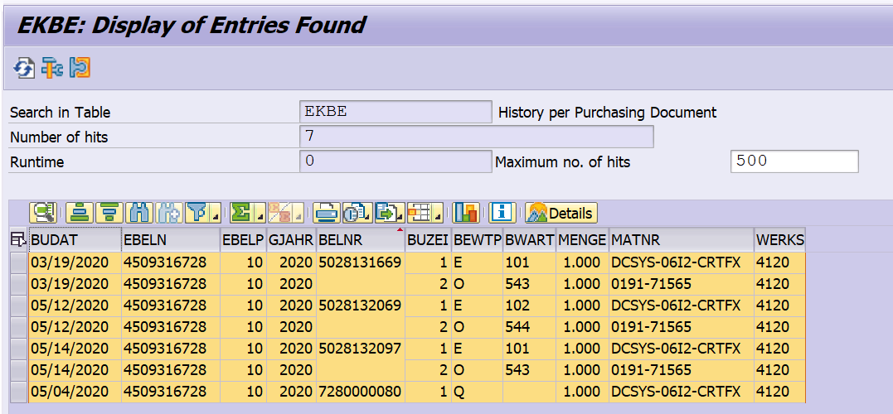

Take all those PO’s and pass to EKPO Table to check whether PO net price <> Zero and Subcon Indicator <EKPO-PSTYP>= 3 then Consider those PO’s. Rest of the PO’s needs to be ignore.

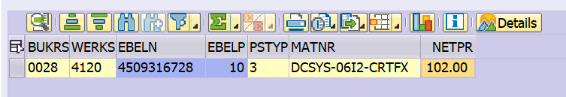

To fetch PO Currency
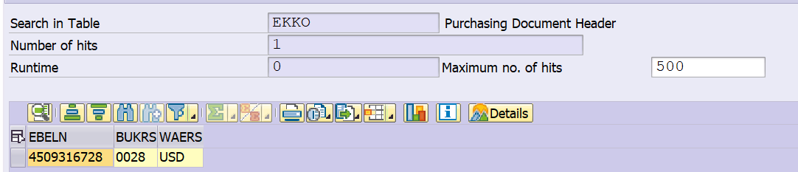

- To get the Accounting document numbers for each Valid Subcon PO we should pass Company code, Year, Posting date range for each, Document type from selection fields and Refrence Doc number <Sorted Material Doc and year combine from EKBE TABLE WHERE EKBE-BWET= E Q and O> and pass to BKPF table to get Accounting Document number, Period, Year and Doc types.

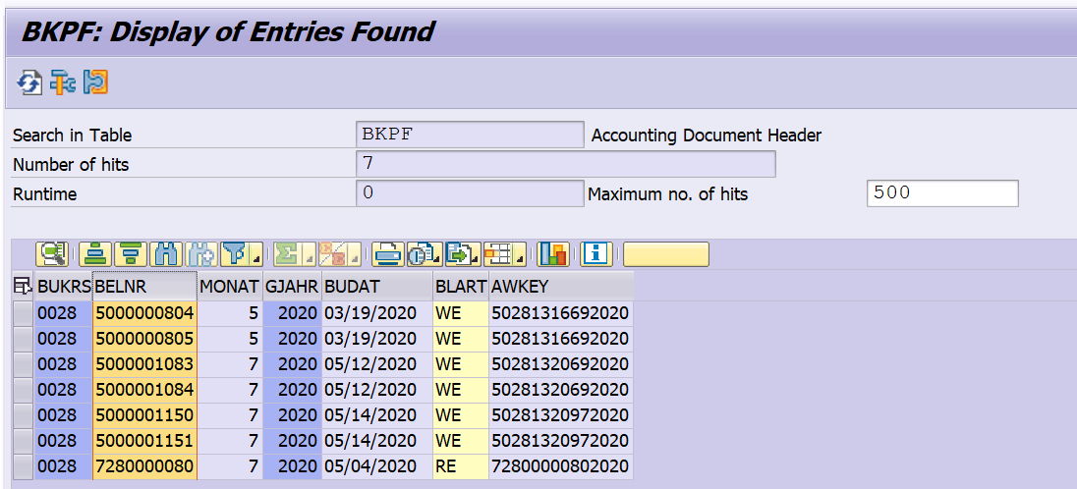

- From BKPF for each PO pass above each Accounting document number, Year, Company codes and GL’s from Selection screen to the BSEG table to get the transaction information. And then go for next Acc doc no#. After going through all Acc doc no then summarize amount by PO and Item to get Total information and then go for next PO.

DMBTR – LC ; DMBE2 -GC and SHKZG – H means Credit (-) and S means Debits (+) sum it up based on the Debits and credits

While going through each Acount document number do Subtotal Amounts by Acc doc number and GL Account and fill the buckets of Material Received (BSV)/Material Consumed GBB and Sub con Fee FRL/FRN and then go for next accounting Doc number and so on. And, at the End subtotal for Each PO and item.

Make sure BSEG Account doc Materials tied to EKET Material doc Materials each other while showing the Amounts in each bucket.

Output should be summarized based upon PO and PO item and show in different color. Complete Layout shown in Report Output

Version 5.0: INC06340089: Fiscal year mismatch b/w Mat doc and Accounting doc

Adding extra logic to convert material document posting date to AMAT Fiscal year so that report can pull all the relevant accounting documents belongs to materials document posting date.

Adding Save button to ALV layout
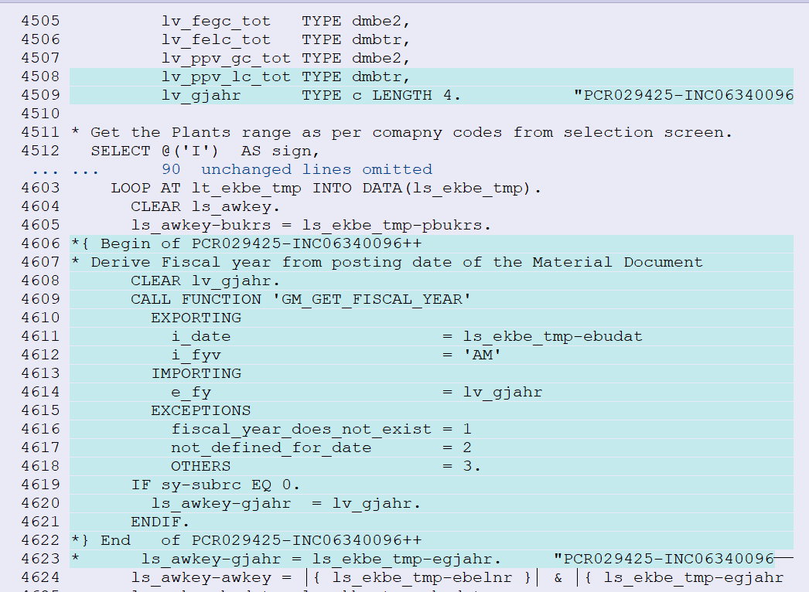

Version 4.0: Defect# 4464: Even though some of the Amounts is Zero.. still we need to summarized based upon PO and PO item and show in different color. Complete Layout shown in Report Output
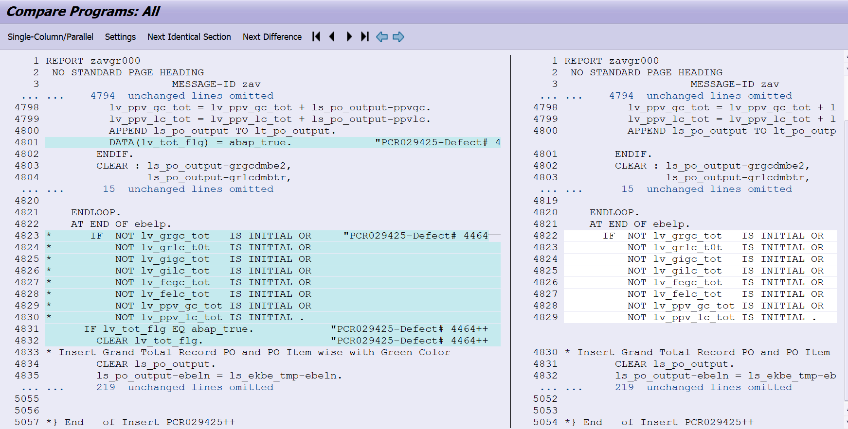

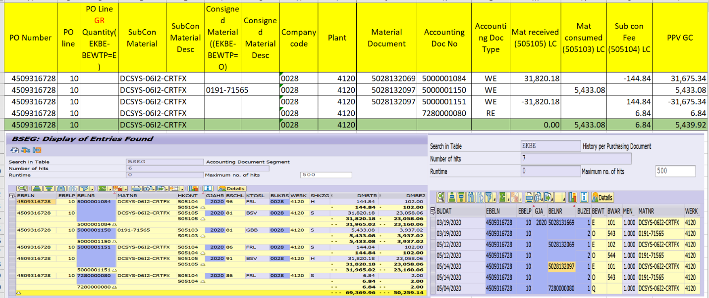

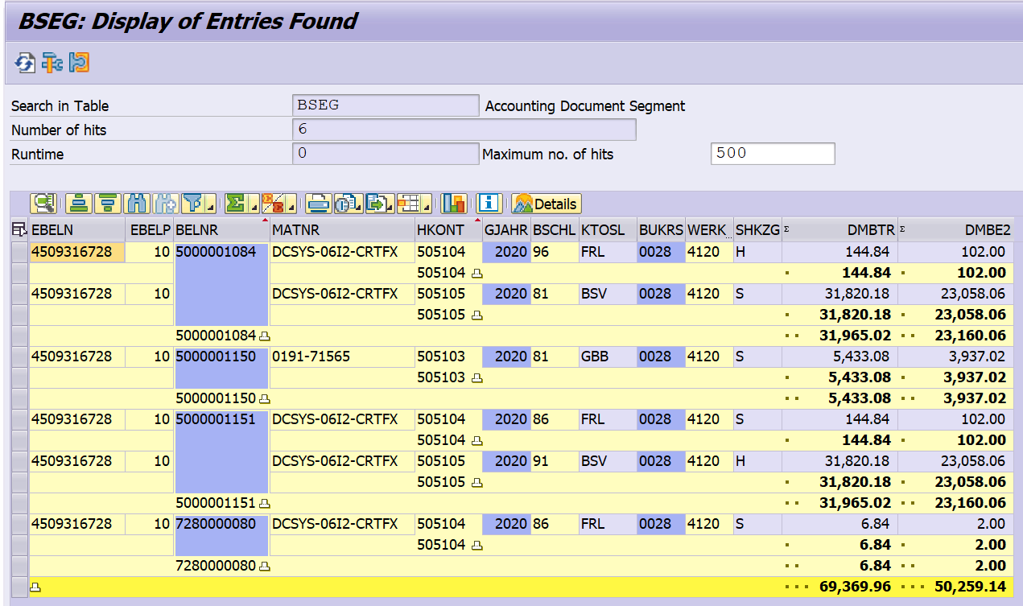

Version 2.0: Diplay all consumed materials in separate lines instead of showing single line.
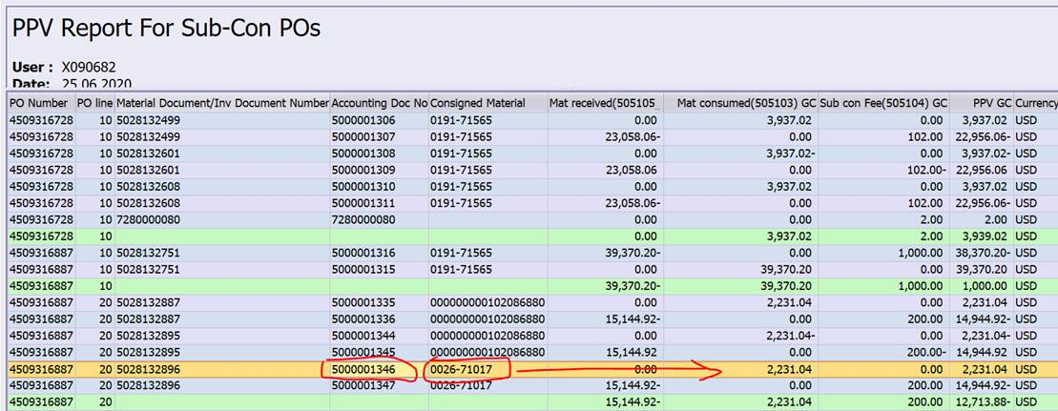
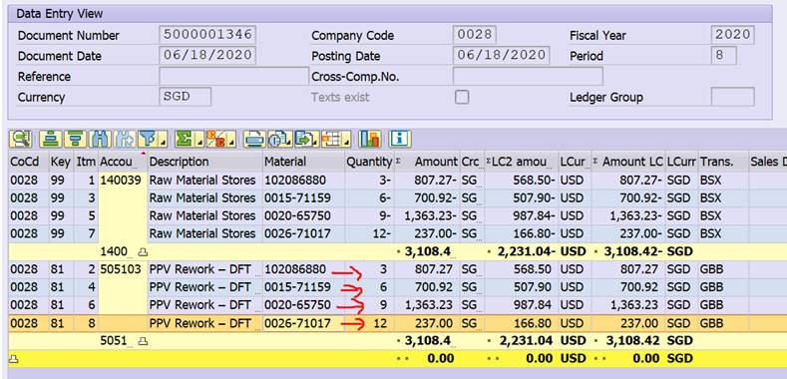

Goto T030 TABLE to get the transaction assigned to GL’s
Transaction BSEG-KTOSL – BSV – Material Received (505105)
Transaction BSEG-KTOSL – GBB– Material Consumed (505103)
Transaction BSEG-KTOSL – FRN/FRL – Sub-con Fee (505104)
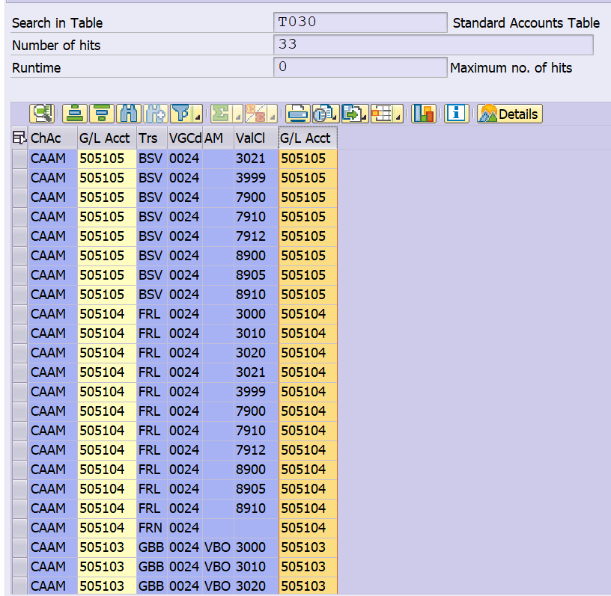

Version 6.0:-
The PO line GR Quantity and PO consigned Quantity are summing up with consigned material and transaction key BSV and GBB respectively.
Before Change :-
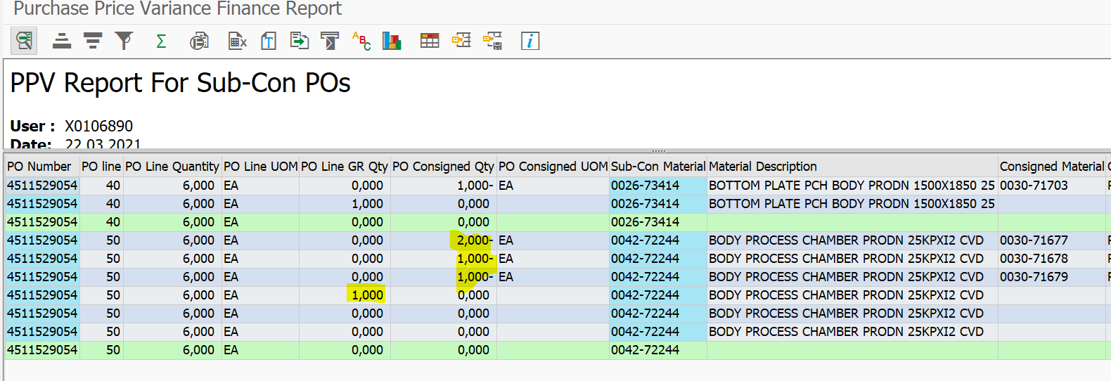
After Change :- 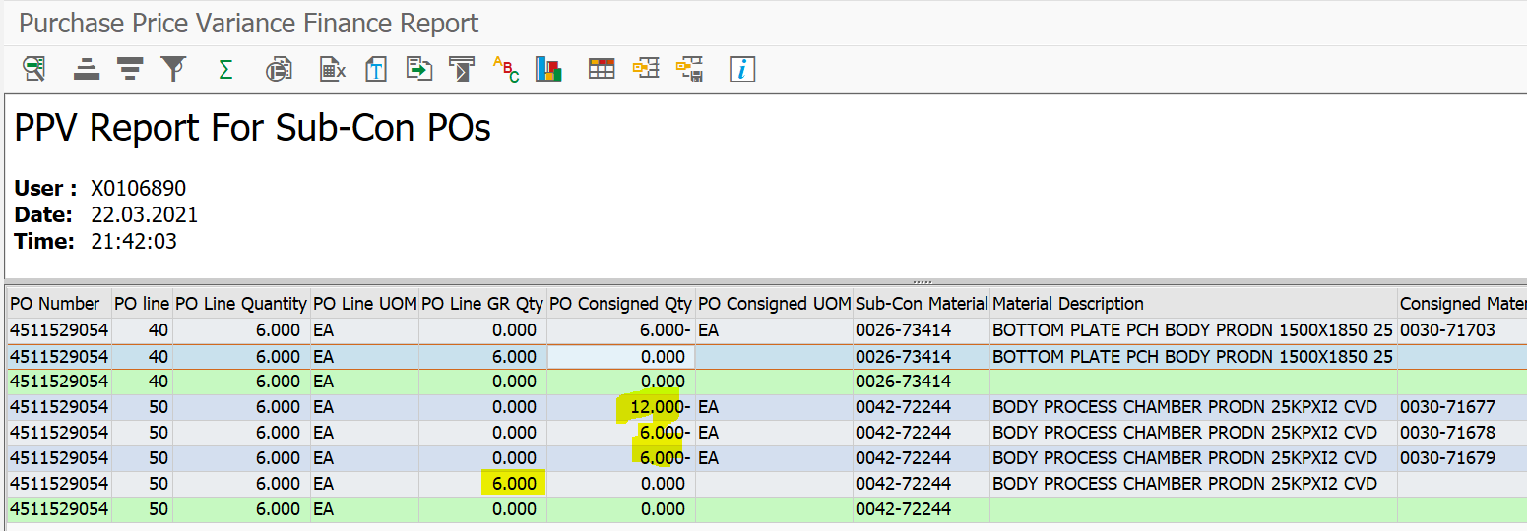

Report output

ALV detail list report

Exception Handling Rules
<Specify instructions to be followed when errors occur, or any processing outside the normal process flow.>

Special Requirements
<Provide any special requirements related to this development effort such as language translations, configurability or personalization allowed, etc.>

Dependencies
<List any dependencies to other technical objects or configuration objects>

Constraints
<Discuss all the constraints or the limitations if any for this technical object>

Scheduling Requirements
<If the specification is for custom program, specify whether jobs should run during off-peak hours, frequency, manual or automatic start. Dependencies, etc>

Test Specification
<This portion of the document is used to plan the unit testing. It includes items such as defining the test participants, the test environment, the schedule, and scope of the testing event.>

Functional Test Scenarios
<Document test scenarios to test all of the functional requirements. Include a test scenario for each different business scenario that may occur.>

ID | Test Scenario | Expected Results | Comments
1 | Execute the report | Validate with Material master, PO History details and Accounting details with report output FAGLL03 Report output
2
3
4
5

Test Data & Other Needs
<If any, specify test data set-up & refresh needs, volume of data, timeliness of data, etc.>

Test System & Environment
<Identify test system and client.>

Test System: | X08 and Q08
Client: | 200

Audit Requirements/Integrity Controls
<Specify the controls that are required to ensure that the data has been processed correctly.>

Security/Authorization Requirements
<Provide any special authorization checking or data security provisions required.>
Not Needed
Following finance roles need to access this report:
Master Role | Master role Name

Technical Section
Version # | Date Modified | Modified By | Brief Description of Change
1.0 | 07/02/2020 | Srinivasa Annapureddy | Implement logic to generate PPV Report for Sub-Con POs in existing Report program ZAVGR000
2.0 | 07/16/2020 | Srinivasa Annapureddy | Added some more fields to ALV report under defect# 3394
3.0 | 08/27/2020 | Srinivasa Annapureddy | Changes in logic at addition of the totals row into output table
4.0 | 12/08/2020 | Srinivasa Annapureddy | Changes in logic to pull data from BKPF table due to fiscal year of Material Document and FI document are mismatching- INC06340089

Author | Srinivasa Annapureddy | Date Created: | 07/02/2020
Functional Team Lead |  | Signature and Date Approved:
Technical Team ASM |  | Signature and Date Approved:
Technical Team Lead | Yvonne Tai | Signature and Date Approved:
Project Manager |  | Signature and Date Approved:

Object Type:
Report ( X) Interface ( ) Conversion ( ) Enhancement ( ) Workflow ( ) Form ( ) WebDynpro ( ) Other ( ) Specify: Tables

ALL Z Objects Information
Object Type | Program
Object Name | ZAVGR000
Object Description | Purchase Price Variance Finance Report
Development Class | ZAVG
Transaction Code | ZAVGR000
Message Class
Other Relevant Information | ZAV
Other Relevant Information | Made changes or enhanced new logic to generate PPV report for Sub-Con Pos.

Detail Technical Specification

Solution: 1) added two option buttons to existing selection screen of the report program.
2) made some enhancements to selection screen functionality as selection of option buttons on the selection screen.
3) Implemented new logic to generate PPV report for Sub-Con POs as per new requirement.

Processing Logic:

I. Selection screen Changes:
1) Added two option buttons, one is to generate PPV report for Finance I.e. existing report program. Second one is to generate PPV report for Sub-Con POs and added some fields and validations as per FS.

PPV report for Finance Selection Screen

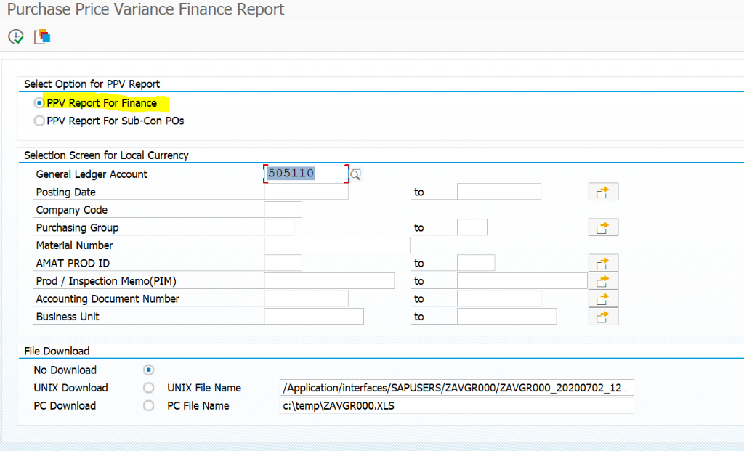
PPV Report for Sub-Con POs selection screen

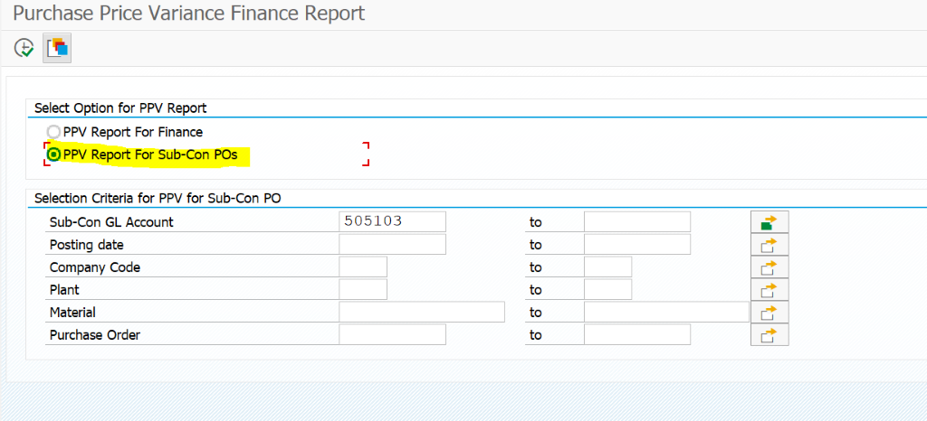

II. Generate PPV report for Sub-Con POs Logic
1) Validations for new added fields at selection screen for option PPV report for Sub-Con POs
2) Prepare the Plants range table as per selection screen plants and company codes range
3) Get the data based selection screen values and from tables EKBE , EKPO , EKKO , LFA1 , MARA , T024 , T001, MAKT, BKPF and BSEG to prepare the output table.

4) Prepare the output table as per PO , PO item , Material Document , Accouting Document and Material wise i.e. GR material and consumed material wise.
5) calculate the addition of amounts from BSEG as per accouting document key(BSV,GBB,FRL and FRL) and received material and consumed material wise.
6) Add the another grand total entry to output table as PO and PO item Wise with Green colour.
7) Display the Output table in ALV display and Grand total entry in Green Colour.

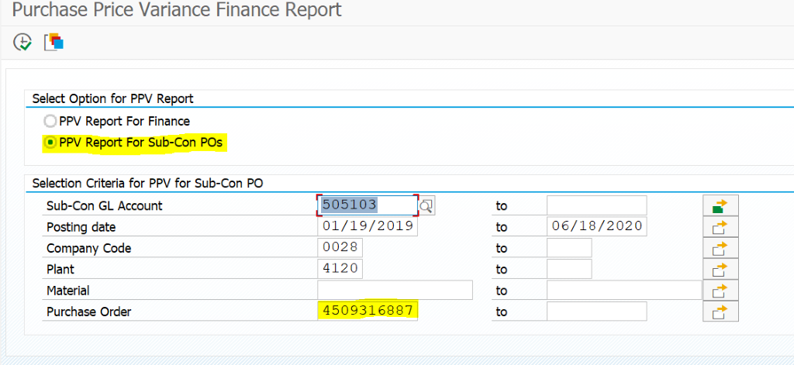
Output
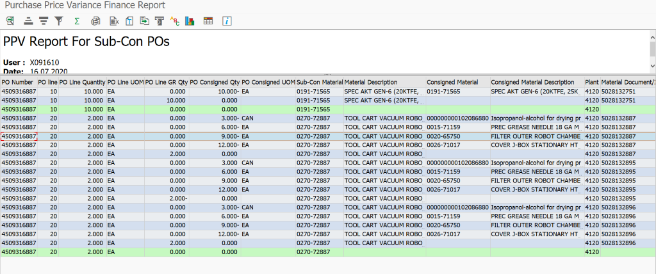

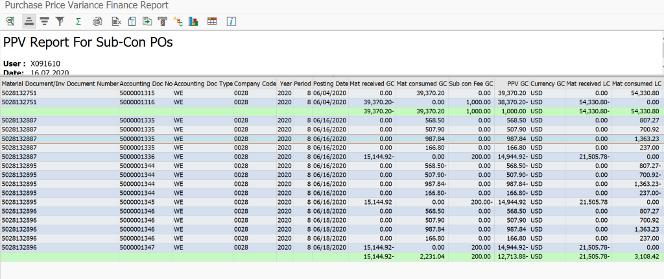
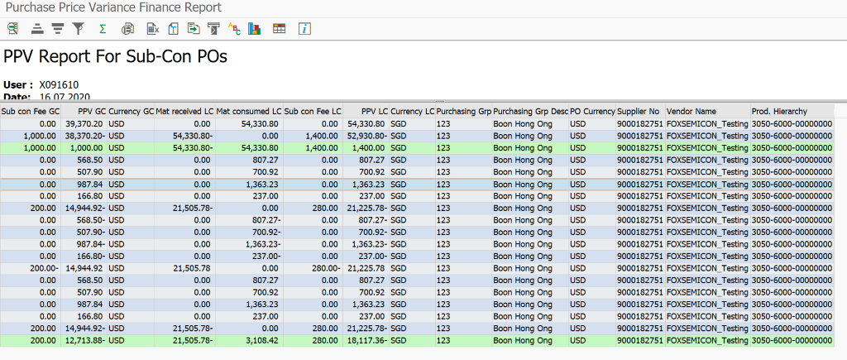

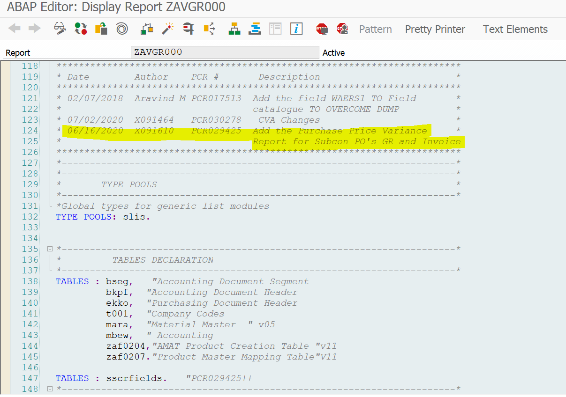

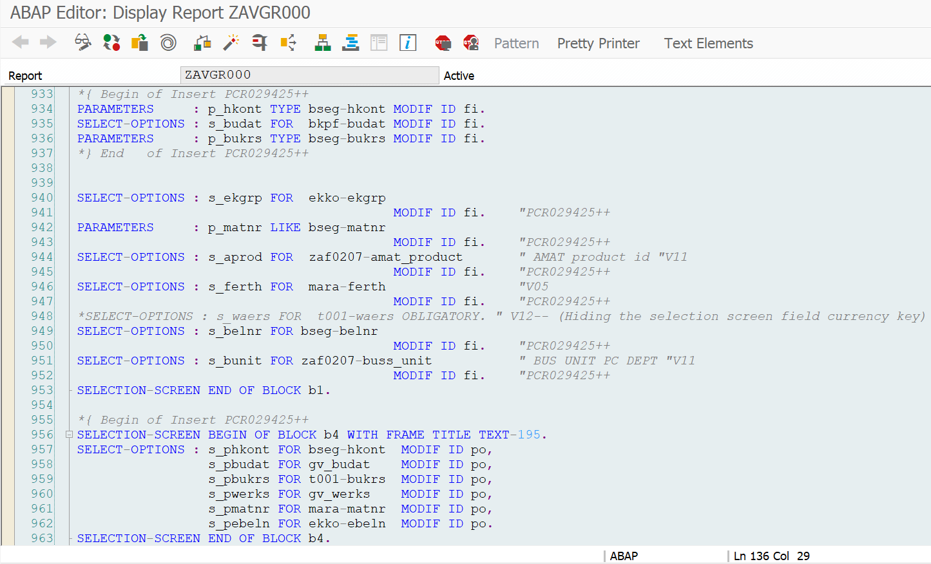
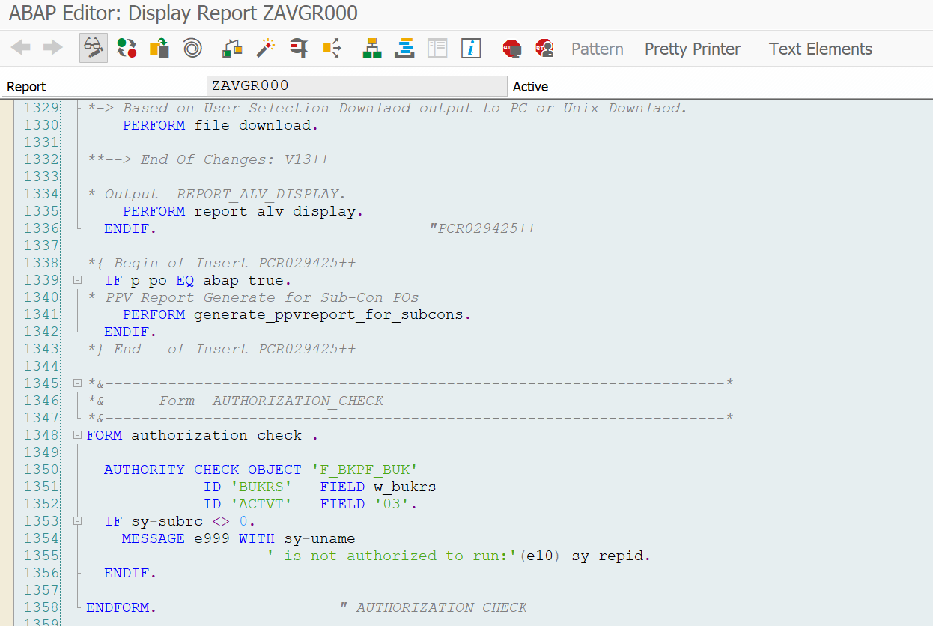
*&---------------------------------------------------------------------*
*& Form UNIX_DEFAULT_FILENAME
*&---------------------------------------------------------------------*
* text
*----------------------------------------------------------------------*
* --> p1 text
* <-- p2 text
*----------------------------------------------------------------------*
FORM unix_default_filename .
*{ Begin of Insert PCR029425++
DATA : lt_phkont TYPE RANGE OF hkont,
ls_phkont LIKE LINE OF lt_phkont.
*} End of Insert PCR029425++
CLEAR: wa_unfil, p_filun.
CONCATENATE '/Application/interfaces/SAPUSERS/ZAVGR000/ZAVGR000'(189) sy-datum sy-uzeit
INTO wa_unfil SEPARATED BY '_'.
IF sy-subrc = 0.
CONCATENATE wa_unfil '.xlsx'(188) INTO wa_unfil.
p_filun = wa_unfil.
ENDIF.
*{ Begin of Insert PCR029425++
* Set the Default G/L Accounts for PPV Report
CLEAR p_hkont.
p_hkont = '505110'.
IF s_phkont[] IS INITIAL.
CLEAR ls_phkont.
ls_phkont-sign = 'I'.
ls_phkont-option = 'EQ'.
ls_phkont-low = '0000505103'.
APPEND ls_phkont TO s_phkont.
CLEAR ls_phkont.
ls_phkont-sign = 'I'.
ls_phkont-option = 'EQ'.
ls_phkont-low = '0000505104'.
APPEND ls_phkont TO s_phkont.
CLEAR ls_phkont.
ls_phkont-sign = 'I'.
ls_phkont-option = 'EQ'.
ls_phkont-low = '0000505105'.
APPEND ls_phkont TO s_phkont.
ENDIF.
*} End of Insert PCR029425++
ENDFORM. " UNIX_DEFAULT_FILENAME
*{ Begin of Insert PCR029425++
*&---------------------------------------------------------------------*
*& Form SELECTION_SCREEN_OUTPUT
*&---------------------------------------------------------------------*
*Description : Modify Selection screen fields as per PPV Report selection
*----------------------------------------------------------------------*
FORM selection_screen_output .
* for PPV Finance Report
IF p_fi EQ abap_false.
sy-title = TEXT-241.
LOOP AT SCREEN.
IF screen-group1 EQ 'FI'.
screen-active = 0.
MODIFY SCREEN.
ENDIF.
ENDLOOP.
ELSE.
* For PPV Sub-Con POs
LOOP AT SCREEN.
IF screen-group1 EQ 'PO'.
screen-active = 0.
MODIFY SCREEN.
ENDIF.
ENDLOOP.
ENDIF.
ENDFORM.
*&---------------------------------------------------------------------*
*& Form GENERATE_PPVREPORT_FOR_SUBCONS
*&---------------------------------------------------------------------*
*Description : Generate PPV Report For Sub-Con POs
*----------------------------------------------------------------------*
FORM generate_ppvreport_for_subcons .
DATA : lt_plants TYPE RANGE OF bwkey,
lt_po_output TYPE TABLE OF ty_po_output,
ls_po_output TYPE ty_po_output,
lt_awkey TYPE TABLE OF ty_awkey,
ls_awkey TYPE ty_awkey,
lt_bseg1 TYPE SORTED TABLE OF ty_bseg1
WITH NON-UNIQUE KEY bukrs belnr gjahr matnr,
lv_awkey TYPE awkey,
lv_grgc_tot TYPE dmbe2,
lv_grlc_t0t TYPE dmbtr,
lv_gigc_tot TYPE dmbe2,
lv_gilc_tot TYPE dmbtr,
lv_fegc_tot TYPE dmbe2,
lv_felc_tot TYPE dmbtr,
lv_ppv_gc_tot TYPE dmbe2,
lv_ppv_lc_tot TYPE dmbtr.
* Get the Plants range as per comapny codes from selection screen.
SELECT @('I') AS sign,
@('EQ') AS option,
bwkey AS low,
@(' ') AS high
FROM t001k
WHERE bwkey IN @s_pwerks
AND bukrs IN @s_pbukrs
INTO TABLE @DATA(lt_plants1).
IF sy-subrc EQ 0.
lt_plants[] = lt_plants1[].
ENDIF.
* Get the Sub-Con POs and Material Documents from table EKBE and EKPO
SELECT ekbe~ebeln AS ebeln,
ekbe~ebelp AS ebelp,
ekbe~zekkn AS zekkn,
ekbe~vgabe AS vgabe,
ekbe~gjahr AS egjahr,
ekbe~belnr AS ebelnr,
ekbe~buzei AS ebuzei,
ekbe~bewtp AS bewtp,
ekbe~budat AS ebudat,
ekbe~matnr AS ematnr,
ekpo~menge AS emenge,
ekpo~meins AS meins,
ekpo~matnr AS matnr,
ekpo~bukrs AS pbukrs,
ekpo~werks AS werks,
ekko~ekgrp AS ekgrp,
ekko~waers AS pwaers,
ekko~lifnr AS lifnr,
lfa1~name1 AS vname,
mara~prdha AS prdha,
t024~eknam AS eknam,
t001~waers AS lcwaers
FROM ekbe INNER JOIN ekpo ON ekbe~ebeln EQ ekpo~ebeln AND
ekbe~ebelp EQ ekpo~ebelp
INNER JOIN ekko ON ekbe~ebeln EQ ekko~ebeln
INNER JOIN lfa1 ON ekko~lifnr EQ lfa1~lifnr
INNER JOIN mara ON ekpo~matnr EQ mara~matnr
INNER JOIN t024 ON ekko~ekgrp EQ t024~ekgrp
INNER JOIN t001 ON ekpo~bukrs EQ t001~bukrs
INTO TABLE @DATA(lt_ekbe)
WHERE ekbe~budat IN @s_pbudat
AND ekpo~bukrs IN @s_pbukrs
AND ekpo~werks IN @lt_plants
AND ( ekpo~matnr IN @s_pmatnr OR ekbe~matnr IN @s_pmatnr )
AND ekbe~ebeln IN @s_pebeln
AND ekpo~pstyp EQ '3'
AND ekpo~netpr NE 0
AND ekbe~bewtp IN ( @gc_bewtp_e, @gc_bewtp_o, @gc_bewtp_q ).
IF sy-subrc EQ 0.
* Get the Material Descriptions for Sub-Con Materials and Consigned Materials
DATA(lt_ekbe_tmp) = lt_ekbe.
SORT lt_ekbe_tmp BY matnr.
DELETE ADJACENT DUPLICATES FROM lt_ekbe_tmp COMPARING matnr.
* Sub-Con Material Descriptions
SELECT matnr,
maktx
FROM makt
INTO TABLE @DATA(lt_makt)
FOR ALL ENTRIES IN @lt_ekbe_tmp
WHERE matnr EQ @lt_ekbe_tmp-matnr
AND spras EQ @sy-langu.
IF sy-subrc EQ 0.
SORT lt_makt BY matnr.
ENDIF.
CLEAR lt_ekbe_tmp.
lt_ekbe_tmp = lt_ekbe.
DELETE lt_ekbe_tmp WHERE bewtp NE gc_bewtp_o.
IF NOT lt_ekbe_tmp IS INITIAL.
SORT lt_ekbe_tmp BY ematnr.
DELETE ADJACENT DUPLICATES FROM lt_ekbe_tmp COMPARING ematnr.
* Get Consigned Materials
SELECT matnr,
maktx
FROM makt
APPENDING TABLE @lt_makt
FOR ALL ENTRIES IN @lt_ekbe_tmp
WHERE matnr EQ @lt_ekbe_tmp-ematnr
AND spras EQ @sy-langu.
IF sy-subrc EQ 0.
SORT lt_makt BY matnr.
ENDIF.
ENDIF.
* Prepare the Accounting Document Keys from Material Documents
CLEAR lt_ekbe_tmp.
lt_ekbe_tmp = lt_ekbe.
SORT lt_ekbe_tmp BY pbukrs ebelnr egjahr ebudat.
DELETE ADJACENT DUPLICATES FROM lt_ekbe_tmp COMPARING pbukrs ebelnr egjahr ebudat.
LOOP AT lt_ekbe_tmp INTO DATA(ls_ekbe_tmp).
CLEAR ls_awkey.
ls_awkey-bukrs = ls_ekbe_tmp-pbukrs.
ls_awkey-gjahr = ls_ekbe_tmp-egjahr.
ls_awkey-awkey = |{ ls_ekbe_tmp-ebelnr }| & |{ ls_ekbe_tmp-egjahr }|.
ls_awkey-budat = ls_ekbe_tmp-ebudat.
APPEND ls_awkey TO lt_awkey.
ENDLOOP.
IF NOT lt_awkey IS INITIAL.
* Get the list of Accounting Documents from BKPF
SELECT bukrs,
belnr,
gjahr,
blart,
monat,
budat,
awkey
FROM bkpf
INTO TABLE @DATA(lt_bkpf)
FOR ALL ENTRIES IN @lt_awkey
WHERE bukrs EQ @lt_awkey-bukrs
AND gjahr EQ @lt_awkey-gjahr
AND budat EQ @lt_awkey-budat
AND awkey EQ @lt_awkey-awkey.
IF sy-subrc EQ 0.
* Get the Items of the Accounting Documents from BSEG
SELECT matnr,
bukrs,
belnr,
gjahr,
buzei,
dmbe2,
dmbtr,
shkzg,
ktosl,
hkont,
erfmg,
erfme
FROM bseg
INTO TABLE @DATA(lt_bseg)
FOR ALL ENTRIES IN @lt_bkpf
WHERE bukrs EQ @lt_bkpf-bukrs
AND belnr EQ @lt_bkpf-belnr
AND gjahr EQ @lt_bkpf-gjahr
AND hkont IN @s_phkont.
IF sy-subrc EQ 0.
SORT lt_bseg BY shkzg.
LOOP AT lt_bseg ASSIGNING FIELD-SYMBOL(<lfs_bseg>).
IF <lfs_bseg>-shkzg EQ gc_h.
<lfs_bseg>-dmbe2 = ( <lfs_bseg>-dmbe2 * -1 ).
<lfs_bseg>-dmbtr = ( <lfs_bseg>-dmbtr * -1 ).
ELSE.
<lfs_bseg>-erfmg = ( <lfs_bseg>-erfmg * -1 ).
ENDIF.
ENDLOOP.
SORT lt_bseg BY bukrs belnr gjahr matnr.
lt_bseg1[] = lt_bseg[].
ENDIF.
ENDIF.
ENDIF.
ELSE.
MESSAGE 'No Data Found for your Selection'(240) TYPE 'I'.
LEAVE LIST-PROCESSING.
ENDIF.
* Prepare the OUTPUT Table for PPV for Sub-Con POs
CLEAR lt_ekbe_tmp.
lt_ekbe_tmp = lt_ekbe.
SORT lt_ekbe_tmp BY ebelnr egjahr.
DELETE ADJACENT DUPLICATES FROM lt_ekbe_tmp COMPARING ebelnr egjahr.
SORT lt_ekbe_tmp BY ebeln ebelp ebelnr egjahr.
SORT lt_ekbe BY ebeln ebelp ebelnr egjahr bewtp ematnr.
SORT lt_bkpf BY awkey.
DATA(lt_bseg2) = lt_bseg.
SORT lt_bseg2 BY bukrs belnr gjahr matnr.
DELETE ADJACENT DUPLICATES FROM lt_bseg2 COMPARING bukrs belnr gjahr matnr.
LOOP AT lt_ekbe_tmp ASSIGNING FIELD-SYMBOL(<lfs_ekbe_tmp>).
CLEAR ls_ekbe_tmp.
ls_ekbe_tmp = <lfs_ekbe_tmp>.
CLEAR ls_po_output.
ls_po_output-ebeln = ls_ekbe_tmp-ebeln. "PO
ls_po_output-ebelp = ls_ekbe_tmp-ebelp. "PO Item
ls_po_output-grmenge = ls_ekbe_tmp-emenge. " GR Qty
ls_po_output-grmeins = ls_ekbe_tmp-meins. "Uom
ls_po_output-matnr = ls_ekbe_tmp-matnr. "Sub-Con Mat
ls_po_output-pwerks = ls_ekbe_tmp-werks. "Plant
ls_po_output-mbelnr = ls_ekbe_tmp-ebelnr. "Material Document
ls_po_output-ekgrp = ls_ekbe_tmp-ekgrp. "Purchage Org
ls_po_output-eknam = ls_ekbe_tmp-eknam. "Purchage Org Name
ls_po_output-pwaers = ls_ekbe_tmp-pwaers. "PO Currency
ls_po_output-lifnr = ls_ekbe_tmp-lifnr. "Vendor
ls_po_output-vname = ls_ekbe_tmp-vname. "Vendor Name
ls_po_output-prdha = ls_ekbe_tmp-prdha. "Product Hierarchy
* Sub-Con Material Description
READ TABLE lt_makt ASSIGNING FIELD-SYMBOL(<lfs_makt>)
WITH KEY matnr = ls_po_output-matnr
BINARY SEARCH.
IF sy-subrc EQ 0.
ls_po_output-pomaktx = <lfs_makt>-maktx.
ENDIF.
* Prepare the Accounting Document Key
CLEAR lv_awkey.
lv_awkey = |{ ls_ekbe_tmp-ebelnr }| & |{ ls_ekbe_tmp-egjahr }|.
* Fill the Accounting Documents for the current Material Document
LOOP AT lt_bkpf INTO DATA(ls_bkpf) WHERE awkey EQ lv_awkey.
ls_po_output-pbukrs = ls_bkpf-bukrs. "Company Code
ls_po_output-abelnr = ls_bkpf-belnr. "Accounting Document
ls_po_output-gjahr = ls_bkpf-gjahr. "Fiscal Year
ls_po_output-budat = ls_bkpf-budat. "Posting Date
ls_po_output-monat = ls_bkpf-monat. "Posting Period
ls_po_output-blart = ls_bkpf-blart. "Accounting Document Type
LOOP AT lt_bseg2 INTO DATA(ls_bseg2) WHERE bukrs EQ ls_bkpf-bukrs
AND belnr EQ ls_bkpf-belnr
AND gjahr EQ ls_bkpf-gjahr.
CLEAR : ls_po_output-cmatnr,
ls_po_output-cmaktx.
* Consigned Material Description
READ TABLE lt_ekbe ASSIGNING FIELD-SYMBOL(<lfs_ekbe>)
WITH KEY ebeln = ls_ekbe_tmp-ebeln
ebelp = ls_ekbe_tmp-ebelp
ebelnr = ls_ekbe_tmp-ebelnr
bewtp = 'O'
ematnr = ls_bseg2-matnr
BINARY SEARCH.
IF sy-subrc EQ 0.
IF <lfs_ekbe>-bewtp EQ 'O'.
ls_po_output-cmatnr = <lfs_ekbe>-ematnr.
READ TABLE lt_makt ASSIGNING <lfs_makt>
WITH KEY matnr = <lfs_ekbe>-ematnr
BINARY SEARCH.
IF sy-subrc EQ 0.
ls_po_output-cmaktx = <lfs_makt>-maktx.
ENDIF.
ENDIF.
ENDIF.
DATA(lt_bseg3) = FILTER #( lt_bseg1 WHERE bukrs EQ ls_bseg2-bukrs
AND belnr EQ ls_bseg2-belnr
AND gjahr EQ ls_bseg2-gjahr
AND matnr EQ ls_bseg2-matnr ).
* Process the Items of the current Accouunting document of the current Material Document
LOOP AT lt_bseg3 INTO DATA(ls_bseg).
CASE ls_bseg-ktosl.
WHEN 'BSV'.
*{ Begin of PCR029425-Defect# 3394++
ls_po_output-pogrqty = ls_bseg-erfmg.
CLEAR : ls_po_output-cmatnr,
ls_po_output-cmaktx.
*} End of PCR029425-Defect# 3394++
ls_po_output-grgcdmbe2 = ls_po_output-grgcdmbe2 + ls_bseg-dmbe2. "GR Amount GC
ls_po_output-grlcdmbtr = ls_po_output-grlcdmbtr + ls_bseg-dmbtr. "GR Amount LC
WHEN 'GBB'.
*{ Begin of PCR029425-Defect# 3394++
IF <lfs_ekbe>-bewtp EQ 'O'.
ls_po_output-poconqty = ls_bseg-erfmg.
CALL FUNCTION 'CONVERSION_EXIT_CUNIT_OUTPUT'
EXPORTING
input = ls_bseg-erfme
IMPORTING
output = ls_po_output-poconuom.
ENDIF.
*} End of PCR029425-Defect# 3394++
ls_po_output-gigcdmbe2 = ls_po_output-gigcdmbe2 + ls_bseg-dmbe2. "GI Amount GC
ls_po_output-gilcdmbtr = ls_po_output-gilcdmbtr + ls_bseg-dmbtr. "GI Amount LC
WHEN 'FRN'.
ls_po_output-fegcdmbe2 = ls_po_output-fegcdmbe2 + ls_bseg-dmbe2. "Sub-Con Fee Amount GC
ls_po_output-felcdmbtr = ls_po_output-felcdmbtr + ls_bseg-dmbtr. "Sub-Con Fee Amount LC
WHEN 'FRL'.
ls_po_output-fegcdmbe2 = ls_po_output-fegcdmbe2 + ls_bseg-dmbe2. "Sub-Con Fee Amount GC
ls_po_output-felcdmbtr = ls_po_output-felcdmbtr + ls_bseg-dmbtr. "Sub-Con Fee Amount LC
WHEN OTHERS.
ENDCASE.
ENDLOOP.
IF sy-subrc EQ 0.
CLEAR lt_bseg3.
ls_po_output-ppvgc = ls_po_output-grgcdmbe2 + ls_po_output-gigcdmbe2 + ls_po_output-fegcdmbe2. "PPV Amt GC
ls_po_output-ppvlc = ls_po_output-grlcdmbtr + ls_po_output-gilcdmbtr + ls_po_output-felcdmbtr. "PPV Amt LC
ls_po_output-gcwaers = 'USD'. "Global Currency
ls_po_output-lcwaers = ls_ekbe_tmp-lcwaers. "Local Currency
* Grand Totals for GR GI PPV and Fee amounts as per PO and PO item
lv_grgc_tot = lv_grgc_tot + ls_po_output-grgcdmbe2.
lv_grlc_t0t = lv_grlc_t0t + ls_po_output-grlcdmbtr.
lv_gigc_tot = lv_gigc_tot + ls_po_output-gigcdmbe2.
lv_gilc_tot = lv_gilc_tot + ls_po_output-gilcdmbtr.
lv_fegc_tot = lv_fegc_tot + ls_po_output-fegcdmbe2.
lv_felc_tot = lv_felc_tot + ls_po_output-felcdmbtr.
lv_ppv_gc_tot = lv_ppv_gc_tot + ls_po_output-ppvgc.
lv_ppv_lc_tot = lv_ppv_lc_tot + ls_po_output-ppvlc.
APPEND ls_po_output TO lt_po_output.
ENDIF.
CLEAR : ls_po_output-grgcdmbe2,
ls_po_output-grlcdmbtr,
ls_po_output-gigcdmbe2,
ls_po_output-gilcdmbtr,
ls_po_output-fegcdmbe2,
ls_po_output-felcdmbtr,
ls_po_output-ppvgc,
ls_po_output-ppvlc,
ls_po_output-gcwaers,
ls_po_output-lcwaers,
ls_po_output-cmatnr,
ls_po_output-cmaktx,
ls_po_output-pogrqty, "PCR029425-Defect# 3394++
ls_po_output-poconqty, "PCR029425-Defect# 3394++
ls_po_output-poconuom. "PCR029425-Defect# 3394++
ENDLOOP.
ENDLOOP.
AT END OF ebelp.
* IF NOT lv_grgc_tot IS INITIAL OR "PCR029425-Defect# 4464--
* NOT lv_grlc_t0t IS INITIAL OR
* NOT lv_gigc_tot IS INITIAL OR
* NOT lv_gilc_tot IS INITIAL OR
* NOT lv_fegc_tot IS INITIAL OR
* NOT lv_felc_tot IS INITIAL OR
* NOT lv_ppv_gc_tot IS INITIAL OR
* NOT lv_ppv_lc_tot IS INITIAL .
* Insert Grand Total Record PO and PO Item wise with Green Color
CLEAR ls_po_output.
ls_po_output-ebeln = ls_ekbe_tmp-ebeln.
ls_po_output-ebelp = ls_ekbe_tmp-ebelp.
ls_po_output-grmenge = ls_ekbe_tmp-emenge.
ls_po_output-grmeins = ls_ekbe_tmp-meins.
ls_po_output-matnr = ls_ekbe_tmp-matnr.
ls_po_output-pwerks = ls_ekbe_tmp-werks.
ls_po_output-ekgrp = ls_ekbe_tmp-ekgrp.
ls_po_output-eknam = ls_ekbe_tmp-eknam.
ls_po_output-pwaers = ls_ekbe_tmp-pwaers.
ls_po_output-lifnr = ls_ekbe_tmp-lifnr.
ls_po_output-vname = ls_ekbe_tmp-vname.
ls_po_output-prdha = ls_ekbe_tmp-prdha.
ls_po_output-grgcdmbe2 = lv_grgc_tot.
ls_po_output-grlcdmbtr = lv_grlc_t0t.
ls_po_output-gigcdmbe2 = lv_gigc_tot .
ls_po_output-gilcdmbtr = lv_gilc_tot .
ls_po_output-fegcdmbe2 = lv_fegc_tot.
ls_po_output-felcdmbtr = lv_felc_tot.
ls_po_output-ppvgc = lv_ppv_gc_tot.
ls_po_output-ppvlc = lv_ppv_lc_tot.
ls_po_output-gcwaers = 'USD'.
ls_po_output-lcwaers = ls_ekbe_tmp-lcwaers.
ls_po_output-color = 'C500'.
APPEND ls_po_output TO lt_po_output.
CLEAR : lv_grgc_tot,
lv_grlc_t0t,
lv_gigc_tot,
lv_gilc_tot,
lv_fegc_tot,
lv_felc_tot,
lv_ppv_gc_tot,
lv_ppv_lc_tot.
* ENDIF. "PCR029425-Defect# 4464--
ENDAT.
ENDLOOP.
* Display PPV Sub-Con PO report in ALV
PERFORM po_ppv_alv_display TABLES lt_po_output.
ENDFORM.
*&---------------------------------------------------------------------*
*& Form PO_PPV_ALV_DISPLAY
*&---------------------------------------------------------------------*
*Description : Diplay Output in ALV Grid
*----------------------------------------------------------------------*
FORM po_ppv_alv_display TABLES pt_po_output STRUCTURE gs_po_output.
IF NOT pt_po_output[] IS INITIAL.
CLEAR gt_po_output.
gt_po_output[] = pt_po_output[].
*Initializes ALV catalog
PERFORM initialize_catalog.
* Build the ALV layout
PERFORM build_layout.
*Displays the data in ALV
PERFORM write_alv.
ELSE.
MESSAGE 'No Data Found for your selection'(252) TYPE 'I'.
LEAVE LIST-PROCESSING.
ENDIF.
ENDFORM.
*&---------------------------------------------------------------------*
*& Form INITIALIZE_CATALOG
*&---------------------------------------------------------------------*
*Description: Fill Field catelalogs for ALV list output
*----------------------------------------------------------------------*
FORM initialize_catalog .
REFRESH gt_fieldcat.
PERFORM populate_field_cat USING:
'0' 'EBELN' TEXT-201, "PO Number
'1' 'EBELP' TEXT-202, "PO line
'2' 'GRMENGE' TEXT-203, "PO Line Quantity
'2' 'GRMEINS' TEXT-204, "PO Line UOM
'2' 'POGRQTY' TEXT-256, "PO Line GR Qty "PCR029425-Defect#3394++
'2' 'POCONQTY' TEXT-257, "PO Consignment Qty "PCR029425-Defect#3394++
'2' 'POCONUOM' TEXT-258, "PO Consignment UOM "PCR029425-Defect#3394++
'3' 'MATNR' TEXT-205, "Sub-Con Material
'4' 'POMAKTX' TEXT-206, "Material Description
'5' 'CMATNR' TEXT-207, "Consigned Material
'6' 'CMAKTX' TEXT-208, "Consigned Material Description
'7' 'PWERKS' TEXT-209, "Plant
'8' 'MBELNR' TEXT-210, "Material Document/Inv Document Number
'9' 'ABELNR' TEXT-211, "Accounting Doc No
'10' 'BLART' TEXT-212, "Accounting Doc Type
'11' 'PBUKRS' TEXT-213, "Company Code
'12' 'GJAHR' TEXT-214, "Year
'13' 'MONAT' TEXT-215, "Period
'14' 'BUDAT' TEXT-216, "Posting Date
'15' 'GRGCDMBE2' TEXT-217, "Mat received(505105) GC
'16' 'GIGCDMBE2' TEXT-218, "Mat consumed(505103) GC
'17' 'FEGCDMBE2' TEXT-219, "Sub con Fee(505104) GC
'18' 'PPVGC' TEXT-220, "PPV GC
'19' 'GCWAERS' TEXT-221, "Currency GC
'20' 'GRLCDMBTR' TEXT-222, "Mat received(505105) LC
'21' 'GILCDMBTR' TEXT-223, "Mat consumed(505103) LC
'22' 'FELCDMBTR' TEXT-224, "Sub con Fee(505104) LC
'23' 'PPVLC' TEXT-225, "PPV LC
'24' 'LCWAERS' TEXT-226, "Currency LC
'25' 'EKGRP' TEXT-227, "Purchasing Grp
'26' 'EKNAM' TEXT-228, "Purchasing Grp Desc
'27' 'PWAERS' TEXT-229, "PO Currency
'28' 'LIFNR' TEXT-230, "Supplier No
'29' 'VNAME' TEXT-231, "Vendor Name
'30' 'PRDHA' TEXT-232. "Prod. Hierarchy
ENDFORM.
*&---------------------------------------------------------------------*
*& Form BUILD_LAYOUT
*&---------------------------------------------------------------------*
*Description: Set Layout settings for ALV
*----------------------------------------------------------------------*
FORM build_layout .
gs_layout-zebra = abap_true.
gs_layout-colwidth_optimize = abap_true.
gs_layout-info_fieldname = c_color.
ENDFORM.
*&---------------------------------------------------------------------*
*& Form WRITE_ALV
*&---------------------------------------------------------------------*
*Description: Display the ALV list output
*----------------------------------------------------------------------*
FORM write_alv .
DATA(lv_repid) = sy-repid.
* To generate the ALV GRID Output.
CALL FUNCTION 'REUSE_ALV_GRID_DISPLAY'
EXPORTING
i_callback_program = lv_repid
* i_grid_title = TEXT-241
i_callback_top_of_page = 'SUB_TOP_OF_PAGE'
is_layout = gs_layout
it_fieldcat = gt_fieldcat
TABLES
t_outtab = gt_po_output
EXCEPTIONS
program_error = 1
OTHERS = 2.
IF sy-subrc <> 0.
MESSAGE ID sy-msgid TYPE sy-msgty NUMBER sy-msgno
WITH sy-msgv1 sy-msgv2 sy-msgv3 sy-msgv4.
ENDIF.
CLEAR: lv_repid.
ENDFORM.
*&---------------------------------------------------------------------*
*& Form POPULATE_FIELD_CAT
*&---------------------------------------------------------------------*
*Description: Populate the Field catalogues for ALV
*----------------------------------------------------------------------*
FORM populate_field_cat USING pv_colpos TYPE sy-cucol
pv_fname TYPE slis_fieldname
pv_seltext TYPE scrtext_l.
DATA: ls_fieldcat TYPE slis_fieldcat_alv. "Field Catalog
CLEAR ls_fieldcat.
MOVE:
pv_colpos TO ls_fieldcat-col_pos,
pv_fname TO ls_fieldcat-fieldname,
pv_seltext TO ls_fieldcat-seltext_l,
'GT_PO_OUTPUT' TO ls_fieldcat-tabname.
APPEND ls_fieldcat TO gt_fieldcat.
CLEAR ls_fieldcat.
ENDFORM. " POPULATE_FIELD_CAT
*&---------------------------------------------------------------------*
*& Form SUB_TOP_OF_PAGE
*&---------------------------------------------------------------------*
*Description: TOP-OF-PAGE event for ALV
*----------------------------------------------------------------------*
FORM sub_top_of_page.
*--Local Work Area
DATA : ls_line TYPE slis_listheader. " Hold list header
* Header
ls_line-typ = c_h.
ls_line-info = 'PPV Report For Sub-Con POs'(241).
APPEND ls_line TO gt_header.
CLEAR ls_line.
* User
ls_line-typ = gc_s.
ls_line-key = 'User :'(233).
ls_line-info = sy-uname.
APPEND ls_line TO gt_header.
CLEAR ls_line.
* Date
ls_line-typ = gc_s.
ls_line-key = 'Date:'(234).
CONCATENATE sy-datum+6(2) '.'
sy-datum+4(2) '.'
sy-datum(4) INTO ls_line-info. "todays date
APPEND ls_line TO gt_header.
CLEAR: ls_line.
* Time
ls_line-typ = gc_s.
ls_line-key = 'Time:'(235).
CONCATENATE sy-uzeit(2) ':'
sy-uzeit+2(2) ':'
sy-datum+4(2) INTO ls_line-info. "todays time
APPEND ls_line TO gt_header.
CLEAR ls_line.
*--This funcation module will display the top of the page
CALL FUNCTION 'REUSE_ALV_COMMENTARY_WRITE'
EXPORTING
it_list_commentary = gt_header.
*--Refresh
REFRESH : gt_header.
ENDFORM. "SUB_TOP_OF_PAGE
Version 5.0:
*} End of Insert PCR029425++

Version 5.0

{ Begin of PCR029425- INC06340089

Issue: FI documents not getting from table BKPF due to fiscal year (GJAHR which is using in where clause for BKPF table) of the Material Documents and FI documents are different. Addition of SAVE option to ALV layout.

Solution: GJAHR which is using in where condition for BKPF table needs to be calculate from posting date of the material document.

Object Type | Program
Object Name | ZAVGR000
Object Description | Purchase Price Variance Finance Report
Development Class | ZAVG
Transaction Code | ZAVGR000
Message Class
Other Relevant Information | ZAV
Other Relevant Information | Made changes or enhanced new logic to generate PPV report for Sub-Con Pos.

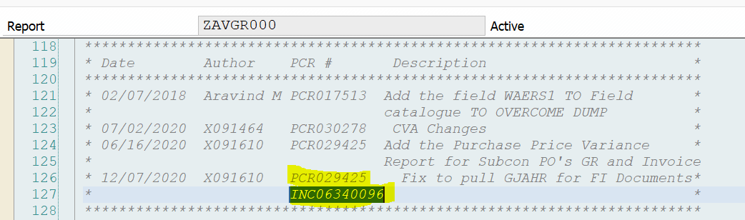
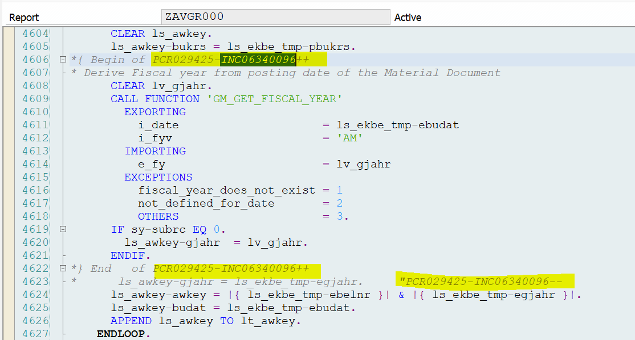

Issue 2: added the SAVE option for ALV Layout and Print Options

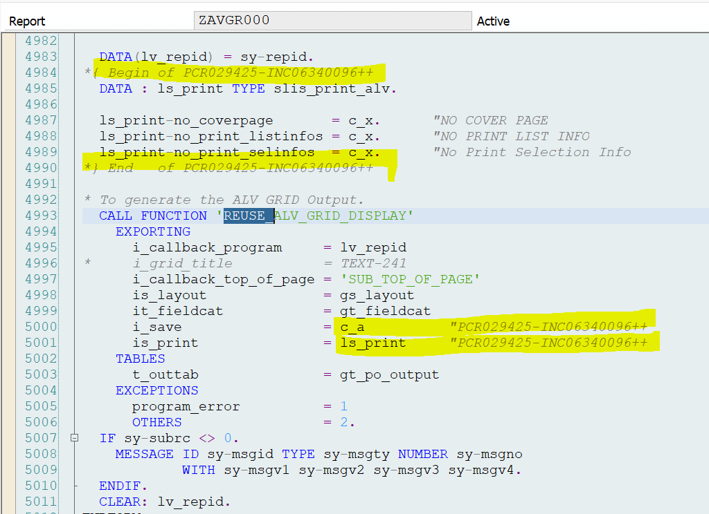

} End of PCR029425- INC06340089

Technical Section

Version # | Date Modified | Modified By  (Name and Employee ID) | <PCR number> - Brief Description of Change
V6.0 | 03/23/2021 | SunilKumar Patti | PCR034478_ Bugfix

Systems:

ECC( X ) BW( ) CRM( ) CUA/GRC( ) EPP( ) GTS( )

HCM( ) MDM( ) PLM( ) SCM( ) SNC( ) SEM( )

SLM( ) SRM ( ) XI( ) Web Method( )

If others, specify ________________________

All Objects Information

Note: If all the objects belong to the same system, the ‘System’ column need not be filled.

Object Name | Object Type | Created/Modified/Auto-generated | Short comments (optional) | System
ZAVGR000 | Executable Report | Changed | Bug Fix : PO line GR Quantity and PO consigned Quantity | D08

Component Workbench Enhancements:

<For frameworks like CRM, Webdynpro, if any object in the component workbench (like component/view/window etc.) is newly created or enhanced, specify them>

Component Name/View name/Context node name/Other Workbench enhancements | Created/Enhanced

Technical Configuration /Setup(if any)
Note: Screenshots are mandatory for technical configuration changes (like SPRO, Runtime Repository Editor, UI config tool etc.)

TVARVC Details:

TVARVC Name | Purpose | Error handling/Validation when data is empty

Other Technical configuration details:

Technical Solution Details

Functional requested

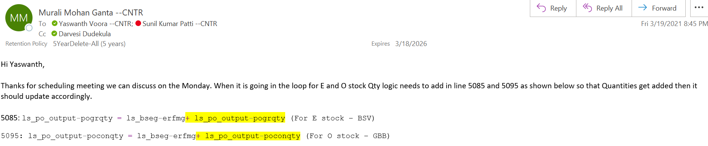

Business requested to change the logic for PO Line GR Qty and PO Consigned Qty as said above.

Cycle Zero Requirements
<Specify the cutover activities, if any>

Error/Exception Handling

Assumptions/Dependencies
<Specify any assumptions made on the requrirements or dependencies, if any>

Security/Authorization Requirements

Open Items / Issues Log / Proposed Solutions (Keep all history)

Item # | Description | Date Opened | Status | Assigned To  <Name> | Comments

Technical Unit test plan:
ID | Test Scenario | Expected Results | Test System  /Environment | Documents used for testing in Dev/QA | Comments
1
2
3
4

